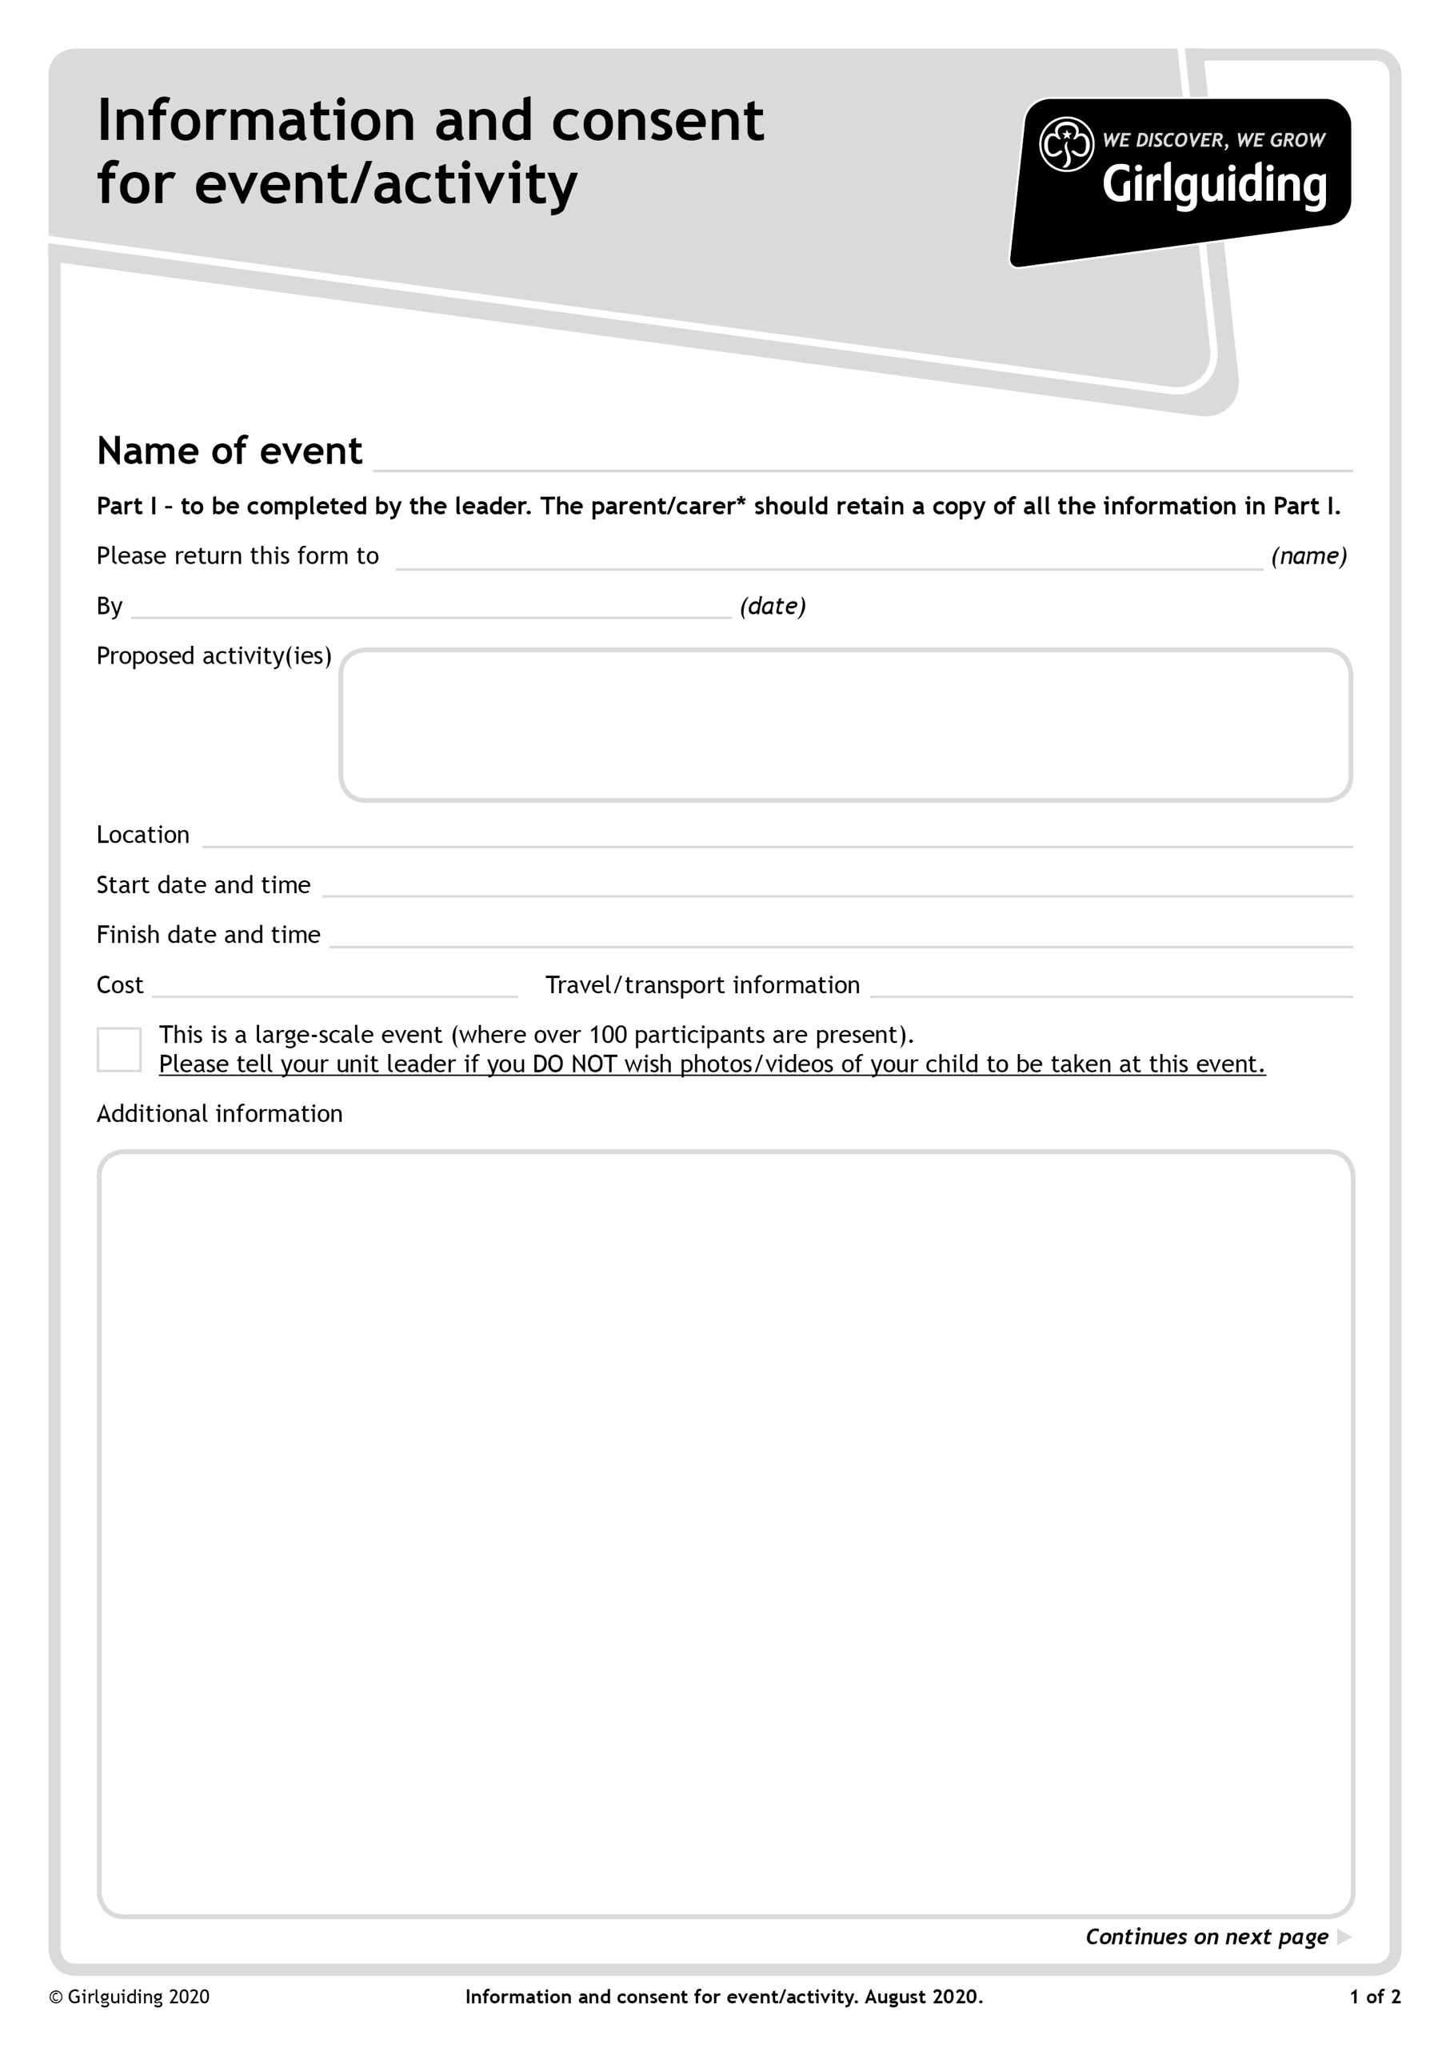

Team Building Activities provided by the Royal Navy

Cooking Camp Donuts

Please wear Uniform

Wear appropriate footwear

Bring water bottle and plastic cup for a hot drink

A sitter or chair for outside

Please wear appropriate clothing for the weather i.e., waterproofs etc.

Own Transport

£5

Saturday 13 November 21 1.30pm

Saturday 13 November 21 9.30am

Yaxley Scout and Guide HQ, Great Drove, Yaxley, Peterborough, PE7 3TW

Wednesday 10th November 2021

County Ranger and Young Leader Navy Fun and Outdoor Cooking

Cambs West County Office – office@ggcw.org.uk

