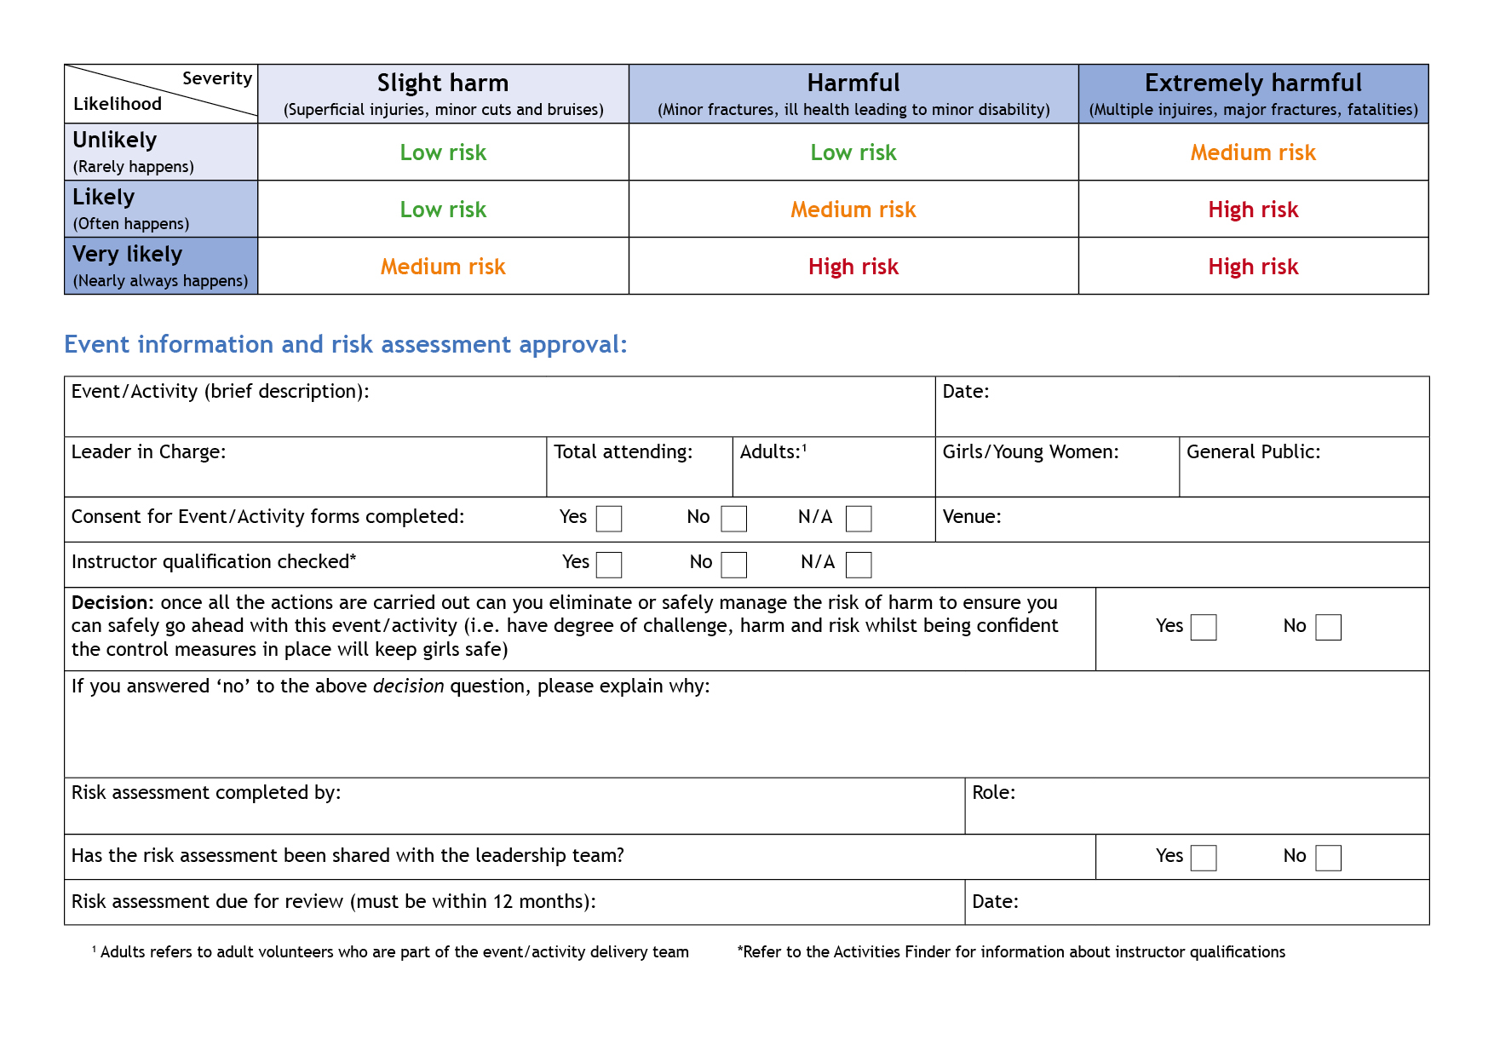
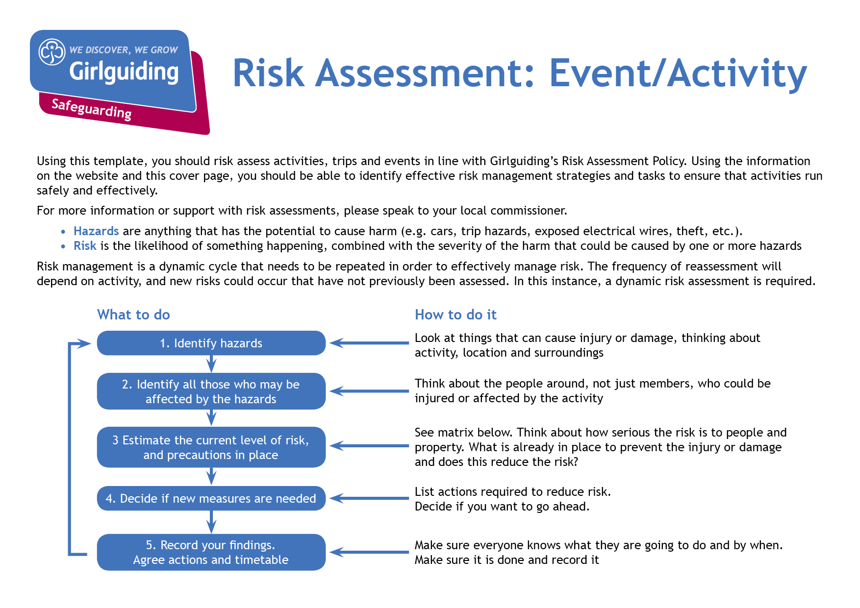

Cambs West County Trip to Cinema
Hazards  What could cause harm or damage? | Who or what is at risk of being affected and how? | What are you already doing?  How have you reduced the risk already? | Likelihood of risk occurring  (L/M/H) | Severity of risk  (L/M/H) | Are further controls necessary?  What else needs to happen to reduce the risk to an acceptable level? | Action by:  name/date
Coronovirus *  From poor respiratory hygiene.  . | All | Hands – girls/leaders to have hand sanitised prior to entering cinema and after leaving building.  Reinforce the catch it, bin it, kill it message.  Encourage everyone to avoid touching their mouth, eyes and nose. | M | H | Leaders to ensure they have sanitizer | Leaders
Ratios * | Girls | Rainbows 1 to 5  Brownies 1 to 8  Guides 1 to 10 | L | M | Leaders to ensure ratios are adhered to. | Leader
Safeguarding * | Girls/All | Seating  To ensure girls are safe and do not leave the auditorium leaders should be sat at each of their girls.  Toileting  Safe space rules apply | M | M | If toileting is required during film, leaders to be aware of safe space rules and accompany girls to toilet and wait outside. | Leader
Fire * | All | Leaders to follow instruction from staff | L | L | Leaders to note fire extinguishers and fire exits n their vicinity  In the event fire alarm is activated and no member of staff leave by nearest exit in an orderly manner | Leader
First Aid * | All | Accident happening to girls or leaders. | L | L | A leader in the group should hold a First Response Course and should carry the unit first aid kit.  Concent forms should be received from parents before attending and the first aider should have sight of these. | Leader
Home Contact * | All | Home contact to be set up (must be a fellow Leader with access to GO) | L | L | Home contact contract on Girlguiding website to be in place and signed appropriately. | Leader

Hazards  What could cause harm or damage? | Who or what is at risk of being affected and how? | What are you already doing?  How have you reduced the risk already? | Likelihood of risk occurring  (L/M/H) | Severity of risk  (L/M/H) | Are further controls necessary?  What else needs to happen to reduce the risk to an acceptable level? | Action by:  name/date
Hazards  What could cause harm or damage? | Who or what is at risk of being affected and how? | What are you already doing?  How have you reduced the risk already? | Likelihood of risk occurring  (L/M/H) | Severity of risk  (L/M/H) | Are further controls necessary?  What else needs to happen to reduce the risk to an acceptable level? | Action by:  name/date
Coach ? | All | Ensure RA gathered from coach company | L |  | Leaders to sit by all exits not bunched together at front.  Girls to wear seat belts. | Leader

