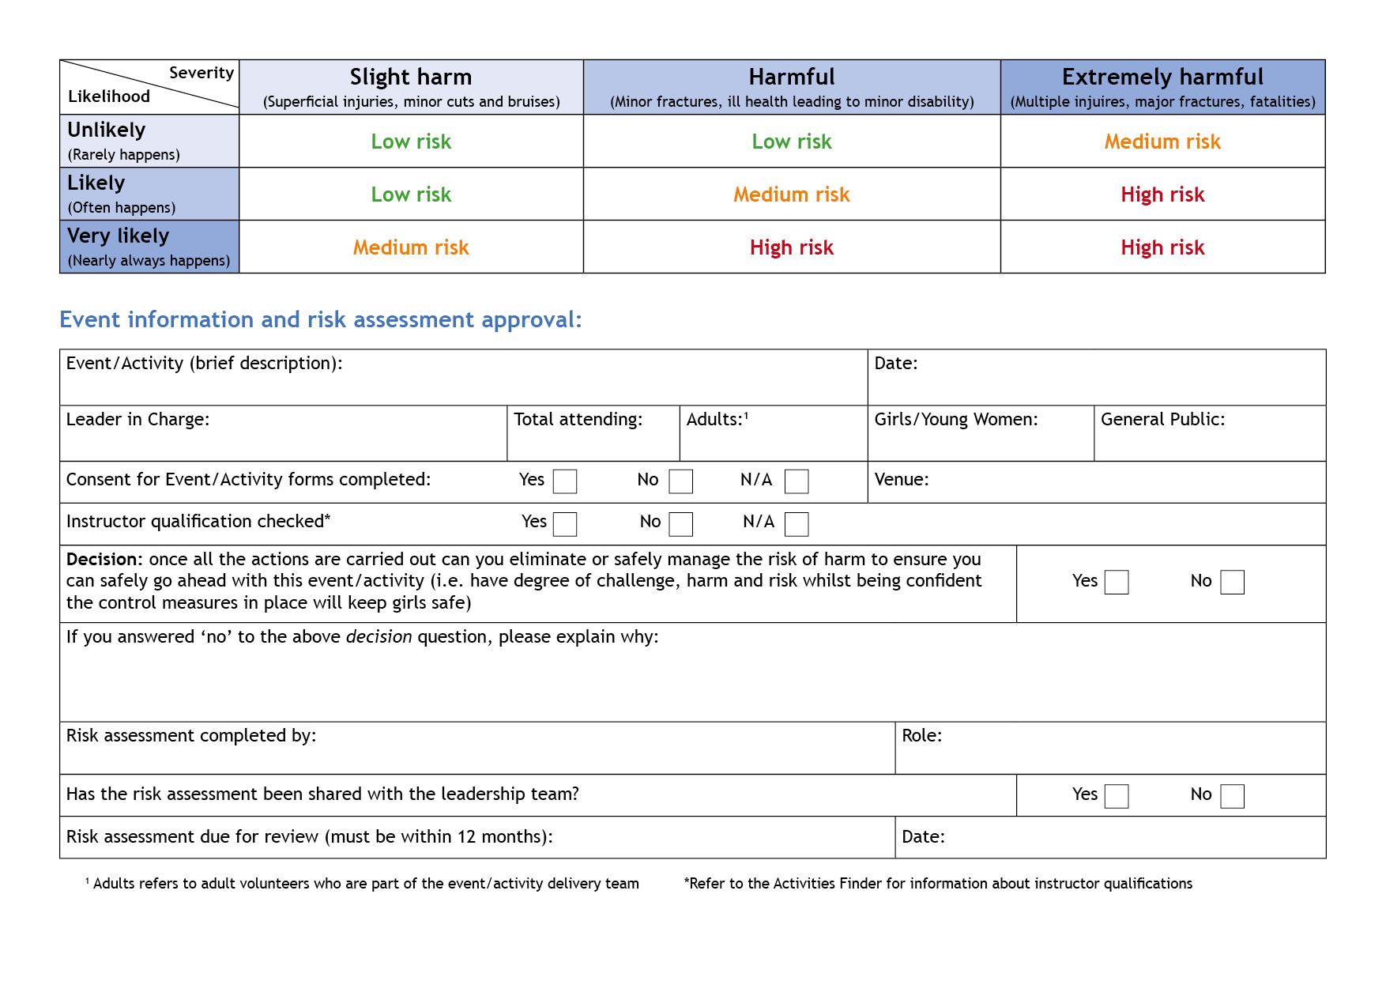

Girlguiding Cambridgeshire West Brownie Space Centre Sleepover

X

x

X

n/a
Morag Sweeney

Lead Volunteer
07/05/2022
09 May 2022
Morag Sweeney
0
163
45
208
National Space Centre, Leicester LN4 5NS
This is an example risk assessment specifically around including COVID-19 considerations – this is partially completed with prompts designed to get you started. This should be used with the resources available on the Girlguiding website and Safe Space training.
Hazards  What could cause harm or damage? | Who or what is at risk of being affected and how? | What are you already doing?  How have you reduced the risk already? | Likelihood of risk occurring  (L/M/H) | Severity of risk  (L/M/H) | Are further controls necessary?  What else needs to happen to reduce the risk to an acceptable level? | Action by:  name/date
Spread of Covid-19 at the event | Girls and adults, plus other people they come into contact with if they become contagious and spread the virus.  People with pre-existing health conditions and older adults are more at risk, plus those who live with people in those groups. | Checked government guidance (links from Girlguiding website) to see how it applies to event.  Provided adequate handwashing facilities and hand sanitizer, instructions on use and additional handwashing opportunities built into programme. | M | H | If the virus risk changes, according to government advice will cancel the event. Consider re-scheduling and/or sending out activities that girls can do at home.  Ensure that all parents and attendees know that they must not attend if they have a high temperature or persistent cough. Any participant showing symptoms of Covid 19 will need to be isolated before being sent home. | Event Team, daily until the event.
Volunteers drop out due to illness or concerns about Covid-19 | There are not sufficient adults to meet ratio requirements or provide adequate care to keep girls safe. | Keep in regular communication with volunteers so that volunteers in lower risk groups can be invited the event can be cancelled earlier if necessary. Ensure that volunteers know it is understandable for them to drop out if they are concerned. Identify other volunteers who could attend at short notice | M | H | If there are not enough volunteers to safely run the event, cancel. | Event Team, daily until the event.
Not Enough Units sign up for the event | Loss of money from County | Constantly review and cancel if necessary before any monies paid | L | M | Review and re-advertise | Event Team / County Office
Participants not arriving in time for coach | Lost time and other participants left waiting outside in the cold | Information sent to Unit Leaders prior to the event informing that that coaches cannot wait for late arrivals. Leaders to inform Parents that if this situation arises they will be responsible for transporting their child to the Space Station. No refunds will be made in this situation. | M | L | Repeat information to Leaders in all correspondence and ask that they communicate clearly with parents. | EventTeam/County Office
Injury caused by road accident, or injury from moving around vehicle | All passengers | No girls should be seated in the front seats  Adults should be seated throughout the coach especially at emergency exits  All passengers to remain seated and facing forward  All passengers to wear seat belts.  Adults to check seatbelts are worn by children  No standing in aisle, lying on seats or in the isle. | L | H | Each coach to have a nominated Lead who ensures the proper procedures are followed | Events Team to inform all Leaders and appoint coach lead.
Fall from a moving vehicle | All passengers | Adults to be seated front, middle and back next to emergency exits.  Adults to monitor exit from vehicle | L | H | Each coach to have a nominated Lead who ensures the proper procedures are followed | Events Team to inform all Leaders and appoint coach lead.
Trip hazard from discarded litter in vehicle | All passengers | Bin bags available throughout vehicle  Bags to be emptied or replaced as often as possible | L | M | Each coach to have a nominated Lead who ensures the proper procedures are followed | Events Team to inform all Leaders and appoint coach lead.
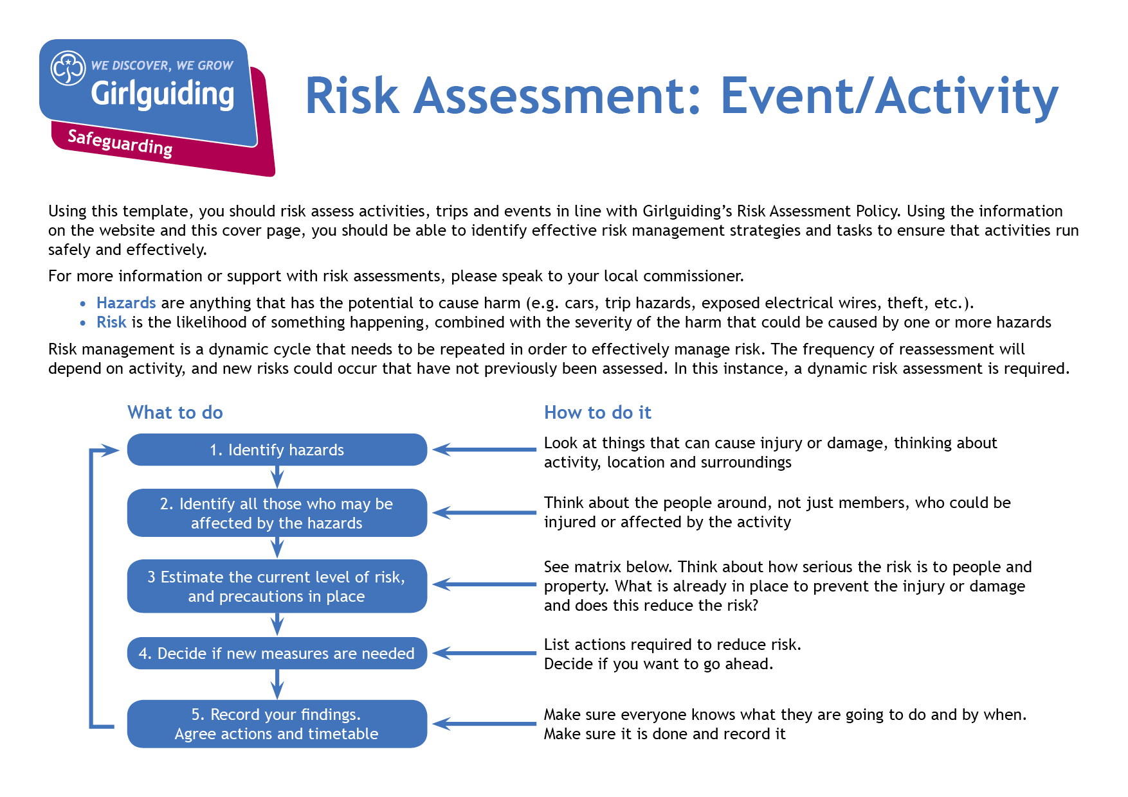  Injury from traffic at stops and breaks | All passengers | Safety instructions given prior to disembarkation.  Ensure Leader exits coach first and leads girls to safety | M | H | Each coach to have a nominated Lead who ensures the proper procedures are followed | Events Team to inform all Leaders and appoint coach lead.
Code of Conduct | All participants | Respect for property should be shown at all times.  Theft and illegal activities will be reported to police.  Girls must not leave the centre unless accompanied by an adult. | L | M | All adults to be fully aware of Girlguiding Code of Conduct | Event Team prior to and during event
Accident | All participants | Initial First Aid will be administered by Unit Leader.  If the leader needs support the Event First Aider can be contacted.  Girls should be accompanied by a leader at all times. | L | M | Each Unit to have First Aid Kit and Health Forms.  Event First Aider will have additional supplies | Event Team and all Leaders at Event
Outbreak of D & V or similar | All participants | Any sign of D & V to be reported immediately to Event First Aider. Isolation is top priority to stop it spreading and protecting other participants.  If required to go home, leaders will be asked to contact parents. | L | L | All adults to be made aware of procedure to follow if a case should arise. | Event Team and all Leaders at Event
Loss and/or damage of personal possessions | All participant | Participants to keep luggage to a minimum. Discourage them from bringing expensive items and inform them these are | L | L | Unit leaders to be made aware that personal possessions are not covered by Girlguiding UK insurance | All participants
Safeguarding | All participants | ALL ADULTS MUST HAVE A DBS CHECK it is the Group Leaders responsibility to ensure they have.  All Adults have a responsibility to ensure that the young people are protected from harm. It will be the responsibility of each adult to ensure that:  • their behaviour is appropriate at all time  • they observe the rules established for the safety and security of young people  • they follow the procedures following suspicion, disclosure or allegation of child abuse  • they recognise the position of trust in which they have been placed  • in every respect, the relationships they form with young people in their care are appropriate  • the welfare of all young people is safeguarded  • they avoid compromising situations or opportunities for misunderstandings or allegations  The code of practice summarised above is there to protect both young people and adults. If you wish to discuss any aspect of the safeguarding policy please contact Event Team | L | M | All adults to be made aware of this risk assessment. | Event Team and all Leaders
Emergency nos.  In case of accident/incident | All adult participants | All units to collect completed Consent and Health forms and keep copy of them with them at all times. Set up Home Contact and keep their details with them during the event.  Morag Sweeney  07801 357701 | L | M | Coach Leaders to check when units board coaches | Event Team to check at event.

Update your risk assessment to take into account the latest health advice around self-isolation rules
Make sure you would have measures in place (agreed with parents) in case pupils or trip supervisors show symptoms and need to self-isolate
Listen to advice from your provider(s) for travel insurance and public liability insurance – if they say cancel, follow their advice
Gather the opinions of parents, pupils and staff – check what the views are on the playground and in the staff room

