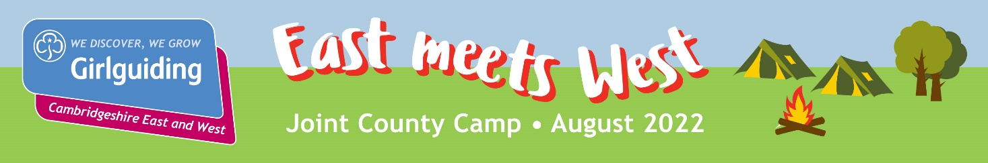

TREFOIL GUILD/ LONE ADULT APPLICATION FORM

Guild Name: |  | County: EAST / WEST
Leader/individual name: | Membership No:
Email:

No Guild members: | No of other leader: |  | No of additional adults:
How many of the adults are male? |  | Additional children:
Age & sex of children:
Are there any special needs we should be aware of and what would they require?

Dates that each person/ family would be staying, and the accommodation required:
Would any of you be willing to help at the event. If so with what:

A non-refundable deposit of £30 for each adult and child 3 years and over should be sent with this application
form to your county office.

Total amount of non-refundable deposit: £ Cheque/ BACS

Girlguiding Cambridgeshire East  3 Quy Court  Colliers Lane  Stow-cum-Quy  CAMBRIDGE  CB25 9AU  office@cambseastguides.org.uk | Girlguiding Cambridgeshire West  Unit 1  Green Farm  Abbots Ripton  HUNTINGDON  PE28 2PF  office@ggcw.org.uk
Bank details for online payment:  Cambs East Guides  30-91-56  00149798  Please use reference “East meets West” | Bank details for online payment:  Cambridgeshire West Guide Association  20-43-63  10086428  Please use reference “East meets West”
Cheques should be made payable to:  Cambs East Guides | Cheques should be made payable to:  Cambridgeshire West Guide Association

